ONLINE VEHICLE PARKING RESERVATION SYSTEM
Scope and Limitations
Department of Computer Science and Engineering, TKR College of Engineering & Technology
Batch C3 (CSE-C) · Academic year [ACADEMIC YEAR]
Table 1: Project team
S.No. | Student name | Roll number
1 | Palle Yashaswini | 23K91A05H9
2 | Mohammed Muneeb Ahmed | 24K95A0518
3 | Kamasani Manisha | 24K95A0513
4 | Pothagani Nithyya Bhargava | 23K91A05J6

Project guide: V Pallavi
Chapter and section numbers quoted in the text (for example Chapter 8 or Section 6.2) refer to the full project report, 17.Final Document. Figures and tables in this document are numbered from 1.

1. SCOPE
The scope follows the six batch objectives and what could be built and measured on one machine. It is stated first as what the product and its measurements cover and then as what they deliberately leave out, so that a simulation or a seeded demonstration is not mistaken for a field result.

1.1 In scope
• Driver accounts with registration, login, roles and a Trust Score; the first account on an empty database becomes the administrator.
• Parking locations with coordinates, capacity, hourly price and a hold-back buffer, managed by the administrator.
• Availability search for an arrival and departure window of up to 30 days, returning the number of bookable bays per location.
• Advance reservation with a forecast-based admission rule, fee quotation by hours, rate and trust multiplier, account credit, cancellation and refund to credit.
• Payment through Stripe Checkout in test mode, or an offline demo checkout when no keys are set.
• Software-managed check-in and check-out, the nearest-alternate move or failed-and-credited outcome on arrival, and the on-time or late decision at departure.
• An administrator console: overview figures, locations, all bookings, users, buffer reset and Strategy Insights.
• Measurement of the engine, the API and five buffer policies by tests, a simulator, latency runs, a concurrency probe and security probes.

1.2 Out of scope
• Physical hardware: barriers, ticket machines, cameras, number-plate recognition and occupancy sensors. Occupancy is whatever the booking records say.
• Passenger-count allocation and the grouping heuristics of the registered base paper.
• Real payments. Stripe is used in test mode only and no money moves.
• A mobile application, push notifications and e-mail receipts.
• Multi-city or multi-operator tenancy, dynamic market pricing and a map interface.
• Machine learning. The insights are deterministic replays of stored bookings, not predictions.

2. ASSUMPTIONS
• Every driver checks in at or near the planned arrival and checks out through the interface; an overstay is recorded only when the driver checks out, using a ten-minute grace period after the booked end.
• A driver who is late to arrive is not penalised; only the departure is judged.
• Locations are independent lots; a driver accepts exactly one suggested alternate and drives to it.
• Distances are straight-line (haversine) from the stored coordinates; road distance and travel time are not used.
• The time zone of a booking is taken as UTC unless the client sends an offset.
• In the simulator, arrival process, lead time (15 to 60 minutes), gaps between parks and the uniform choice of area are assumptions fixed before the runs, because [2] does not state them; bad drivers overstay by exactly one hour.
• The seeded demo history is generated by app/seed.py with a fixed random seed and is synthetic; it demonstrates the mechanism, not real demand.
• A single backend process with one SQLite file serves all requests.

3. LIMITATIONS

Data and evidence
• Synthetic data. The only data are the seeded demo history (9 users, 5 locations, 347 reservations over 60 days plus eight Friday peaks at one lot) and the simulator's own generated runs. No real parking lot data were available.
• The simulator is not SUMO. It re-creates the scenario of [2] with stated assumptions, so its numbers are not comparable with the figures of that paper, which are given only as charts.
• No user study. Ease of use, trust in the Trust Score and acceptance of the alternate move were not tested with real drivers or operators.
• Measured on one machine. All timings come from a 12th-generation Intel Core i5-12500 with 15.7 GB of RAM, a single uvicorn process and SQLite; a load test beyond eight threads was not run.

Defects found by the project's own probes
• Over-booking race. In 10 trials of 20 simultaneous requests for one bookable bay, 1 trial accepted 2 bookings. The admission count and the insert are not atomic, so the claim that double bookings are prevented holds for sequential requests only.
• Unauthenticated payment confirmation. GET /api/payments/demo-confirm marks any reservation paid; the probe turned a pending payment to paid without a token. It exists for the offline demo and must be disabled when real keys are used.
• Default token secret. A token signed with the shipped development secret was accepted as an administrator; the secret must be set in the environment.
• No login rate limit. Thirty wrong passwords in a row were all answered with 401 and the correct password then worked.
• Loose time validation. A booking whose window lies in the past was accepted, and a check-in 25 days before the booked window was accepted.
• Slow list routes. Listing a driver's bookings takes 180 ms and the administrator's booking list 273 ms because each row issues two further queries.

Behaviour that differs from the base paper or from the objectives
• The buffer grows on on-time checkouts, the opposite direction to the paper; the measured effect is in Chapter 8.
• The suspension rule re-applies at every request while the score is below 1.5 and a warning is less than 14 days old, so a suspended driver is locked out for at least 14 days after the last warning, not for one session.
• The alternate booking is created as active without checking the alternate's physical bays; in the simulator this produced alternate-overflow events at the highest overstay shares.
• Objective 1 asks for vehicle profile management and objective 4 for digital receipts. ParkSure has neither a vehicle profile nor a downloadable receipt.
• Availability is a forecast from bookings, not a live reading, because there are no sensors; "real-time" in objective 2 therefore means up to date with the booking records.
Two figures show the limitations that matter most for reading the numbers. The first shows what happens at the gate when half of the drivers overstay: the nearest-alternate step absorbs most overflow, but alternates can themselves be physically full because the shipped code does not re-check their bays. The second shows the concurrency probe: twenty simultaneous requests for a window with one bookable bay occasionally let two bookings through, because the admission check and the insert are not atomic.
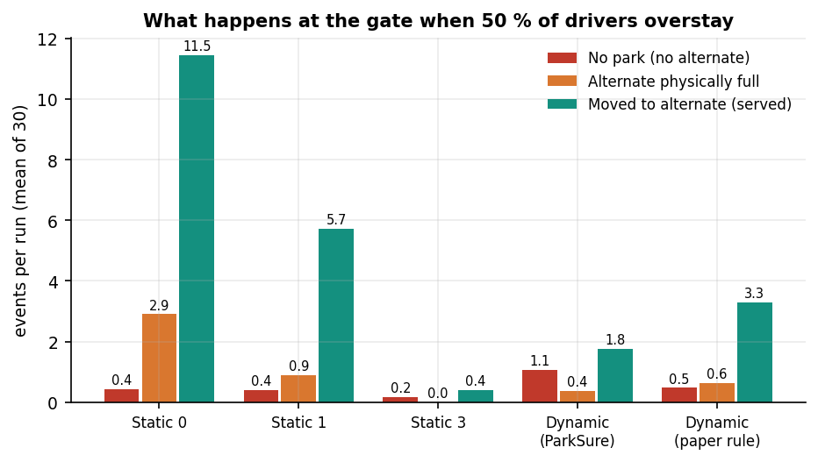
Figure 1: Arrival outcomes per policy when 50 % of the drivers overstay (simulator, 30 runs).
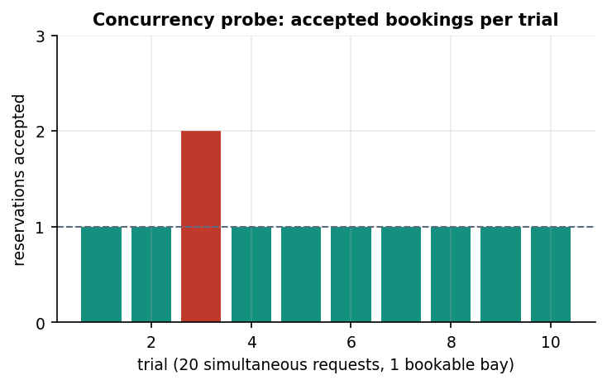
Figure 2: Accepted bookings per trial in the concurrency probe (one bookable bay, twenty simultaneous requests).

4. WHAT WAS NOT MEASURED
The following were not measured, and no figure for them appears in any document:
• Behaviour under real parking demand or against a real operator's data.
• A SUMO run of the base paper's scenario, and any comparison with its figures beyond the qualitative ordering.
• Load beyond eight concurrent threads, multi-process or multi-machine deployment, and a database other than SQLite.
• Stripe in live mode, real webhooks with signing secrets, refunds through the payment provider and receipt generation.
• Usability, accessibility audit tooling and a study with drivers or operators.
• Hardware integration: gates, sensors, cameras and number-plate recognition.
• The effect of the fee multiplier on driver behaviour, since drivers in the simulator do not react to price or to suspension.

